Java 8 streams cheat sheet:

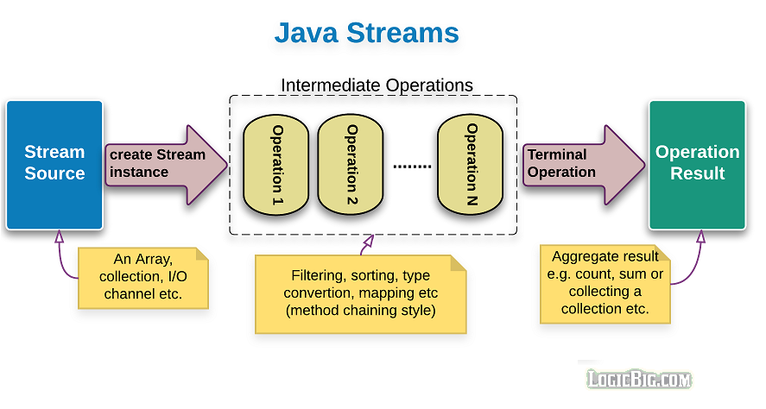

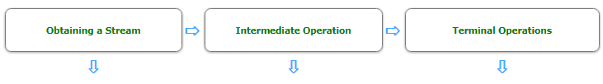

|  |  |  |
| --- | --- | --- |
| [**Collection**](https://docs.oracle.com/javase/8/docs/api/java/util/Collection.html)  stream()  parallelStream()  [**Stream**](https://docs.oracle.com/javase/8/docs/api/java/util/stream/Stream.html)  [**IntStream**](https://docs.oracle.com/javase/8/docs/api/java/util/stream/IntStream.html)  [**LongStream**](https://docs.oracle.com/javase/8/docs/api/java/util/stream/LongStream.html)  [**DoubleStream**](https://docs.oracle.com/javase/8/docs/api/java/util/stream/DoubleStream.html)  static generate()Unordered  static of(..)  static empty()  static iterate(..)  static concat(..)  static builder()  [**IntStream**](https://docs.oracle.com/javase/8/docs/api/java/util/stream/IntStream.html)  [**LongStream**](https://docs.oracle.com/javase/8/docs/api/java/util/stream/LongStream.html)  static range(..)  static rangeClosed(..)  [**Arrays**](https://docs.oracle.com/javase/8/docs/api/java/util/Arrays.html)  static stream(..)  [**BufferedReader**](https://docs.oracle.com/javase/8/docs/api/java/io/BufferedReader.html)  lines(..)  [**Files**](https://docs.oracle.com/javase/8/docs/api/java/nio/file/Files.html)  static lines(..)  static list(..)  static walk(..)  static find(..)  [**JarFile**](https://docs.oracle.com/javase/8/docs/api/java/util/jar/JarFile.html)  stream()  [**ZipFile**](https://docs.oracle.com/javase/8/docs/api/java/util/zip/ZipFile.html)  stream()  [**Pattern**](https://docs.oracle.com/javase/8/docs/api/java/util/regex/Pattern.html)  splitAsStream(..)  [**SplittableRandom**](https://docs.oracle.com/javase/8/docs/api/java/util/SplittableRandom.html)  ints(..)Unordered  longs(..)Unordered  doubles(..)Unordered  [**Random**](https://docs.oracle.com/javase/8/docs/api/java/util/Random.html)  ints(..)  longs(..)  doubles(..)  [**ThreadLocalRandom**](https://docs.oracle.com/javase/8/docs/api/java/util/concurrent/ThreadLocalRandom.html)  ints()  longs(..)  doubles(..)  [**BitSet**](https://docs.oracle.com/javase/8/docs/api/java/util/BitSet.html)  stream()  [**CharSequence**](https://docs.oracle.com/javase/8/docs/api/java/lang/CharSequence.html) (String)  IntStream chars()  IntStream codePoints()  [**StreamSupport**](https://docs.oracle.com/javase/8/docs/api/java/util/stream/StreamSupport.html) (low level)  StaticdoubleStream(..)  static intStream(..)  static longStream(..)  static stream(..) | [**BaseStream**](https://docs.oracle.com/javase/8/docs/api/java/util/stream/BaseStream.html)  sequential()  parallel()  unordered()  onClose(..)  [**Stream**](https://docs.oracle.com/javase/8/docs/api/java/util/stream/Stream.html)  filter(..)  map(..)  mapToInt(..)  mapToLong(..)  mapToDouble(..)  flatMap(..)  flatMapToInt(..)  flatMapToLong(..)  flatMapToDouble(..)  distinct()stateful  sorted(..)stateful  peek(..)  limit(..)stateful,  short-circuiting  skip(..)stateful  *IntStream, LongStream and DoubleStream have similar methods as Stream does but with different args.  Here are some extra methods:*  [**IntStream**](https://docs.oracle.com/javase/8/docs/api/java/util/stream/IntStream.html)  mapToObj(..)  asLongStream()  asDoubleStream()  boxed()  [**LongStream**](https://docs.oracle.com/javase/8/docs/api/java/util/stream/LongStream.html)  mapToObj(..)  asDoubleStream()  boxed()  [**DoubleStream**](https://docs.oracle.com/javase/8/docs/api/java/util/stream/DoubleStream.html)  mapToObj(..)  boxed() | [**BaseStream**](https://docs.oracle.com/javase/8/docs/api/java/util/stream/BaseStream.html)  iterator()  spliterator()  [**Stream**](https://docs.oracle.com/javase/8/docs/api/java/util/stream/Stream.html)  forEach(..)  forEachOrdered(..)  toArray(..)  reduce(..)  collect(..)  min(..)  max(..)  count()  anyMatch(..)short-circuiting  allMatch(..)short-circuiting  noneMatch(..)short-circuiting  findFirst()short-circuiting  findAny()short-circuiting,  nondeterministic  *IntStream, LongStream and DoubleStream have similar methods as Stream does but with different args.  Here are some extra methods:*  [**IntStream**](https://docs.oracle.com/javase/8/docs/api/java/util/stream/IntStream.html)  [**LongStream**](https://docs.oracle.com/javase/8/docs/api/java/util/stream/LongStream.html)  [**DoubleStream**](https://docs.oracle.com/javase/8/docs/api/java/util/stream/DoubleStream.html)  sum()  average()  summaryStatistics() |